Additional Task – (LO1) – Assignment (Task 6)
As you have done this in a previous unit all you need to do is validate the index.html page, stylesheet.css page using the web services below. Update any critical errors found.
All the HTML, CSS & JavaScript should be standards compliant and validate against current W3C standards.
Save to docs sub-folder & submit to Canvas on completion

Visit -The W3C Markup Validation Service - Screenshot showing HTML Validation of index.html page.
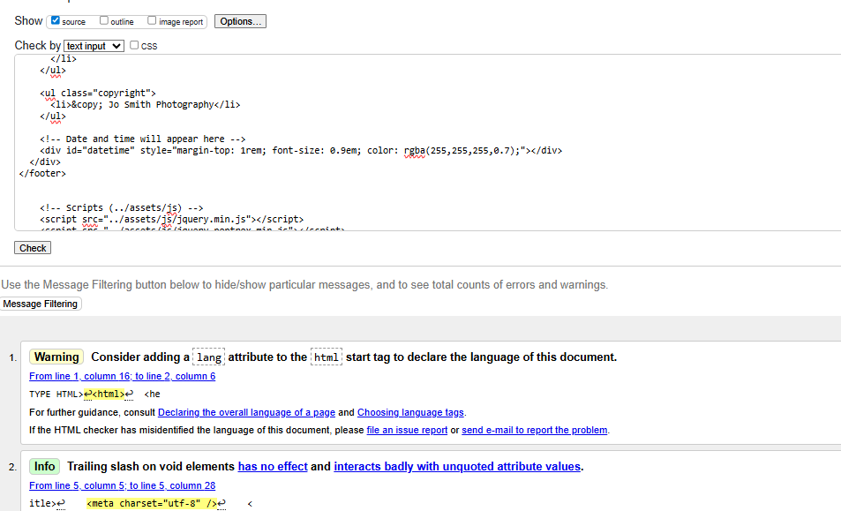
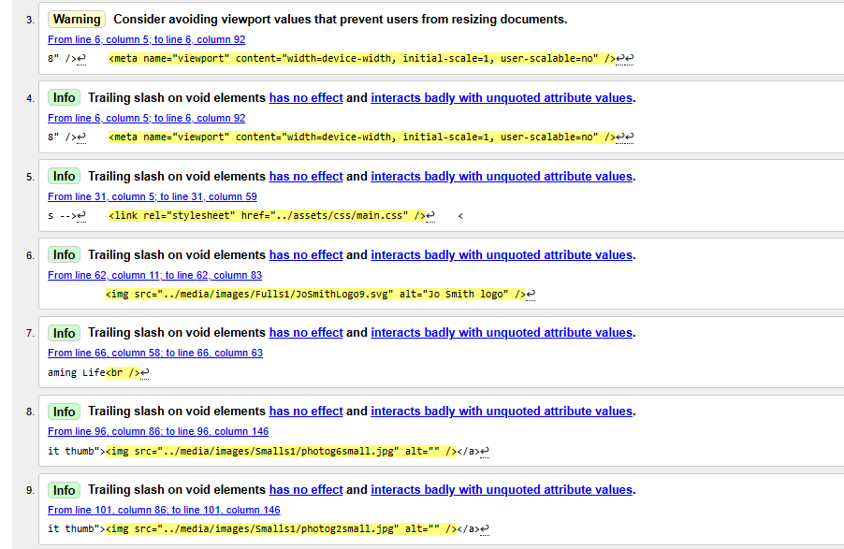
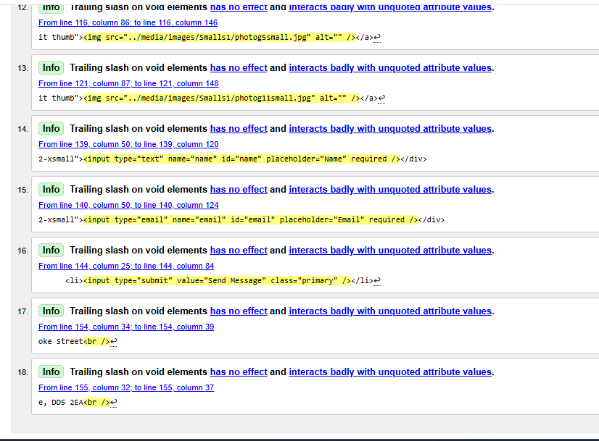

Visit - The W3C CSS Validation Service - Screenshot showing CSS Validation of styles.css page.
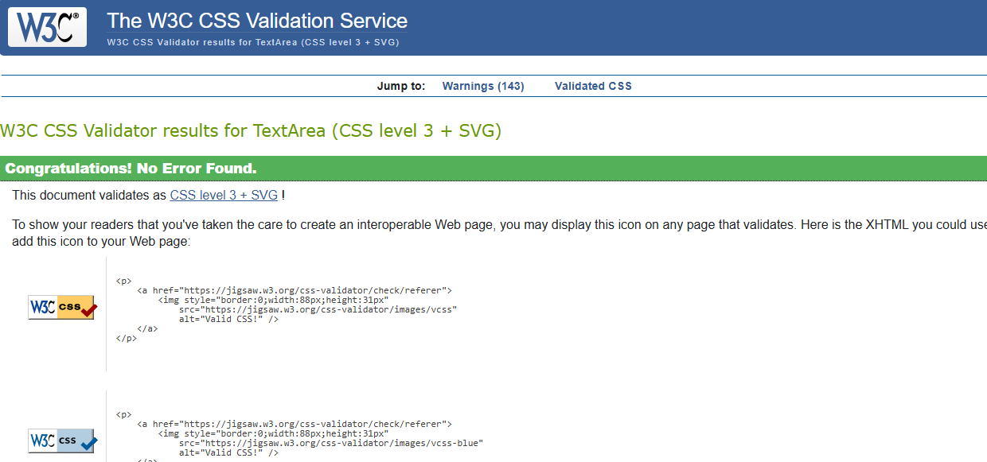

Visit - Best JavaScript Validator Online - Screenshot showing JavaScript Code Validation of any JavaScript Coding that you have used.
